**DS18B20 Waterproof Temperature Sensor**

Jonah Gonzales

Automated Nutrient Technique (ANT)

10/18/2021

**Overview:** The DS18B20 is a waterproof digital temperature sensor. Our specific model from GikFun has an accuracy range from -10° C to 85° C. For our purposes, we are not expecting temperatures that are much cooler or warmer than room temperature (18° -25° C) which fits well within the stated accurate range. The following schematic, from Arduino’s website, demonstrates the connection used. A 4.7k ohm resistor is needed to act as a pull-up for the circuit.

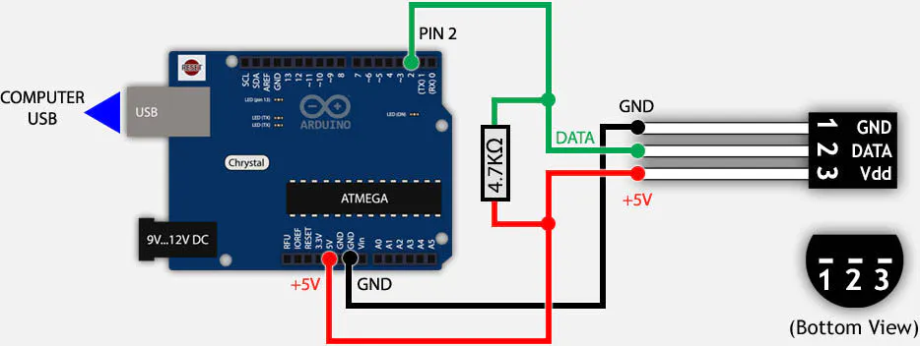

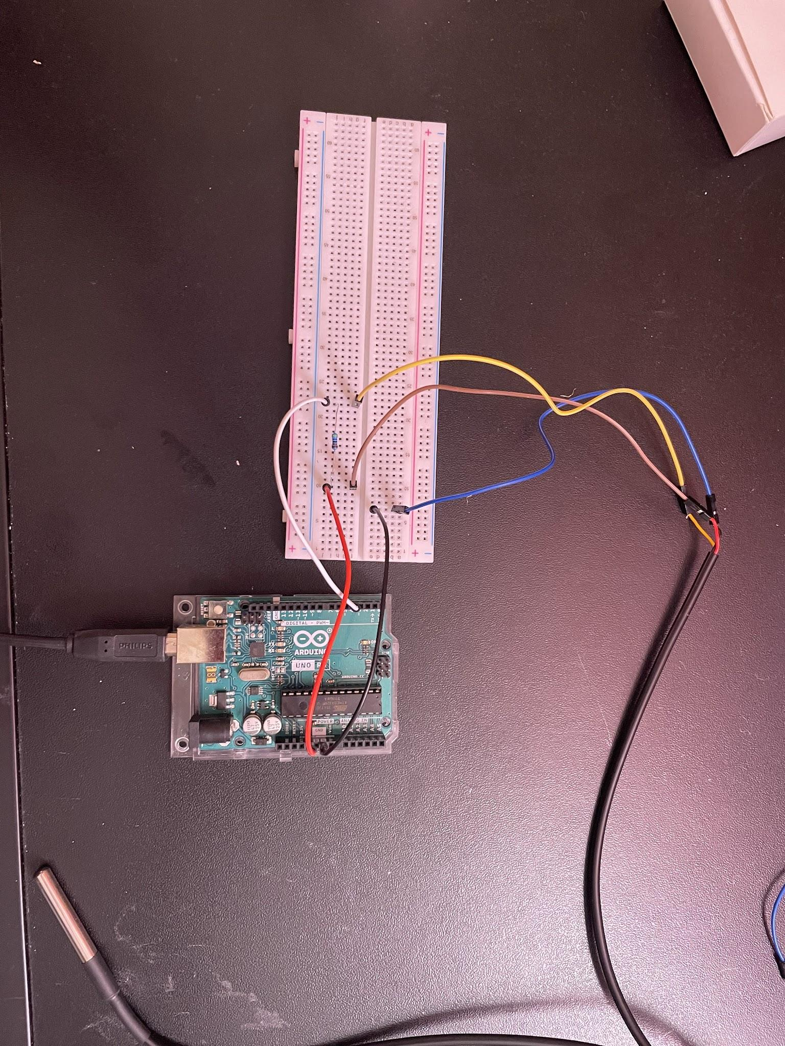

**Above: Schematic for DS18B20 - Red -> 5V, Green-> Digital Port 2, Black -> Ground (Arduino)**

**Below: Actual connected DS18B20. Red -> 5V, Yellow -> Digital Port 4, Black -> Ground**

**Sample Code:** (Libraries and Test Code found on Arduino Website)

#include <OneWire.h>

#include <DallasTemperature.h>

/********************************************************************/

#define Temp_Sensor 4

/********************************************************************/

OneWire oneWire(Temp_Sensor);

/********************************************************************/

DallasTemperature sensors(&oneWire);

void setup() {

Serial.begin(9600);

Serial.println("Dallas Temperature IC Control Library Demo");

sensors.begin();

}

void loop() {

/********************************************************************/

Serial.print(" Requesting temperatures...");

sensors.requestTemperatures(); // Send the command to get temperature readings

Serial.println("DONE");

/********************************************************************/

Serial.print("Temperature is: ");

Serial.print(sensors.getTempCByIndex(0));

delay(1000);

}

**Tests**

**Open Air:**

Expecting between 23° -25° C, as the house’s heater was on, so it was a little bit warmer in the room than average room temperature.

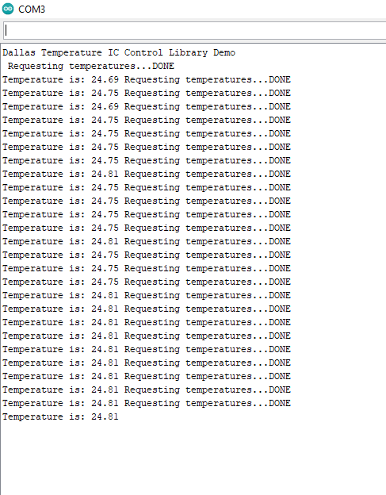

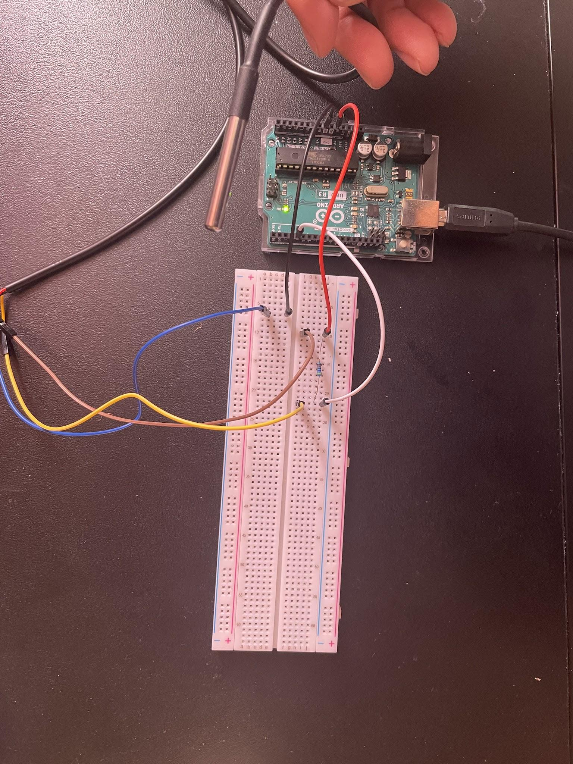

**Left: Arduino Serial Monitor. Results for the open air test seem to be within reason.**

**Right: Sensor in open bedroom air.**

**Tap Water Test:**

Expecting values closer to standard room temperature (20° - 22° C)

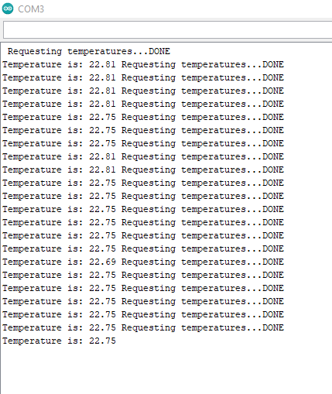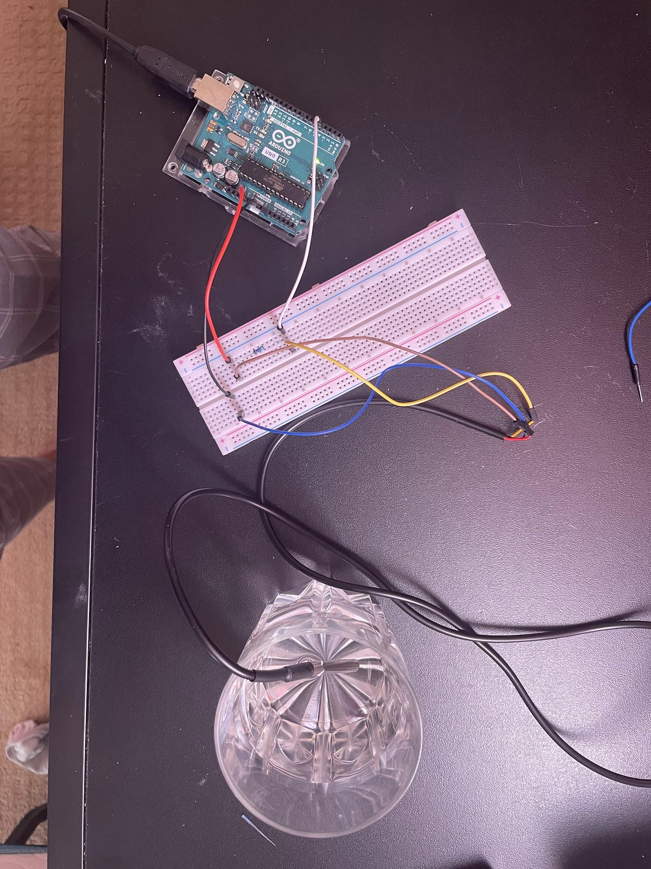

**Left: Results from tap water test. Temperatures appear within reason.**

**Right: Test probe in tap water.**

**Ice Water Test:**

I gave the tap water a minute to cool down, so we are expecting temperatures much lower than the 22° degrees we got straight from the tap, and approaching 0° C

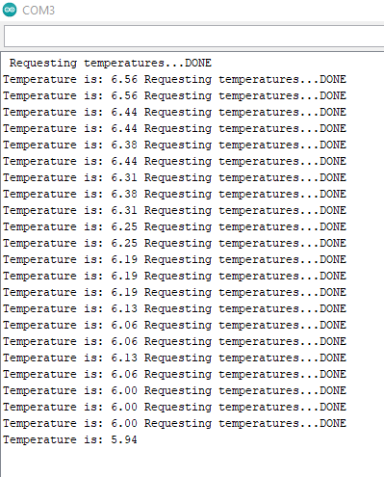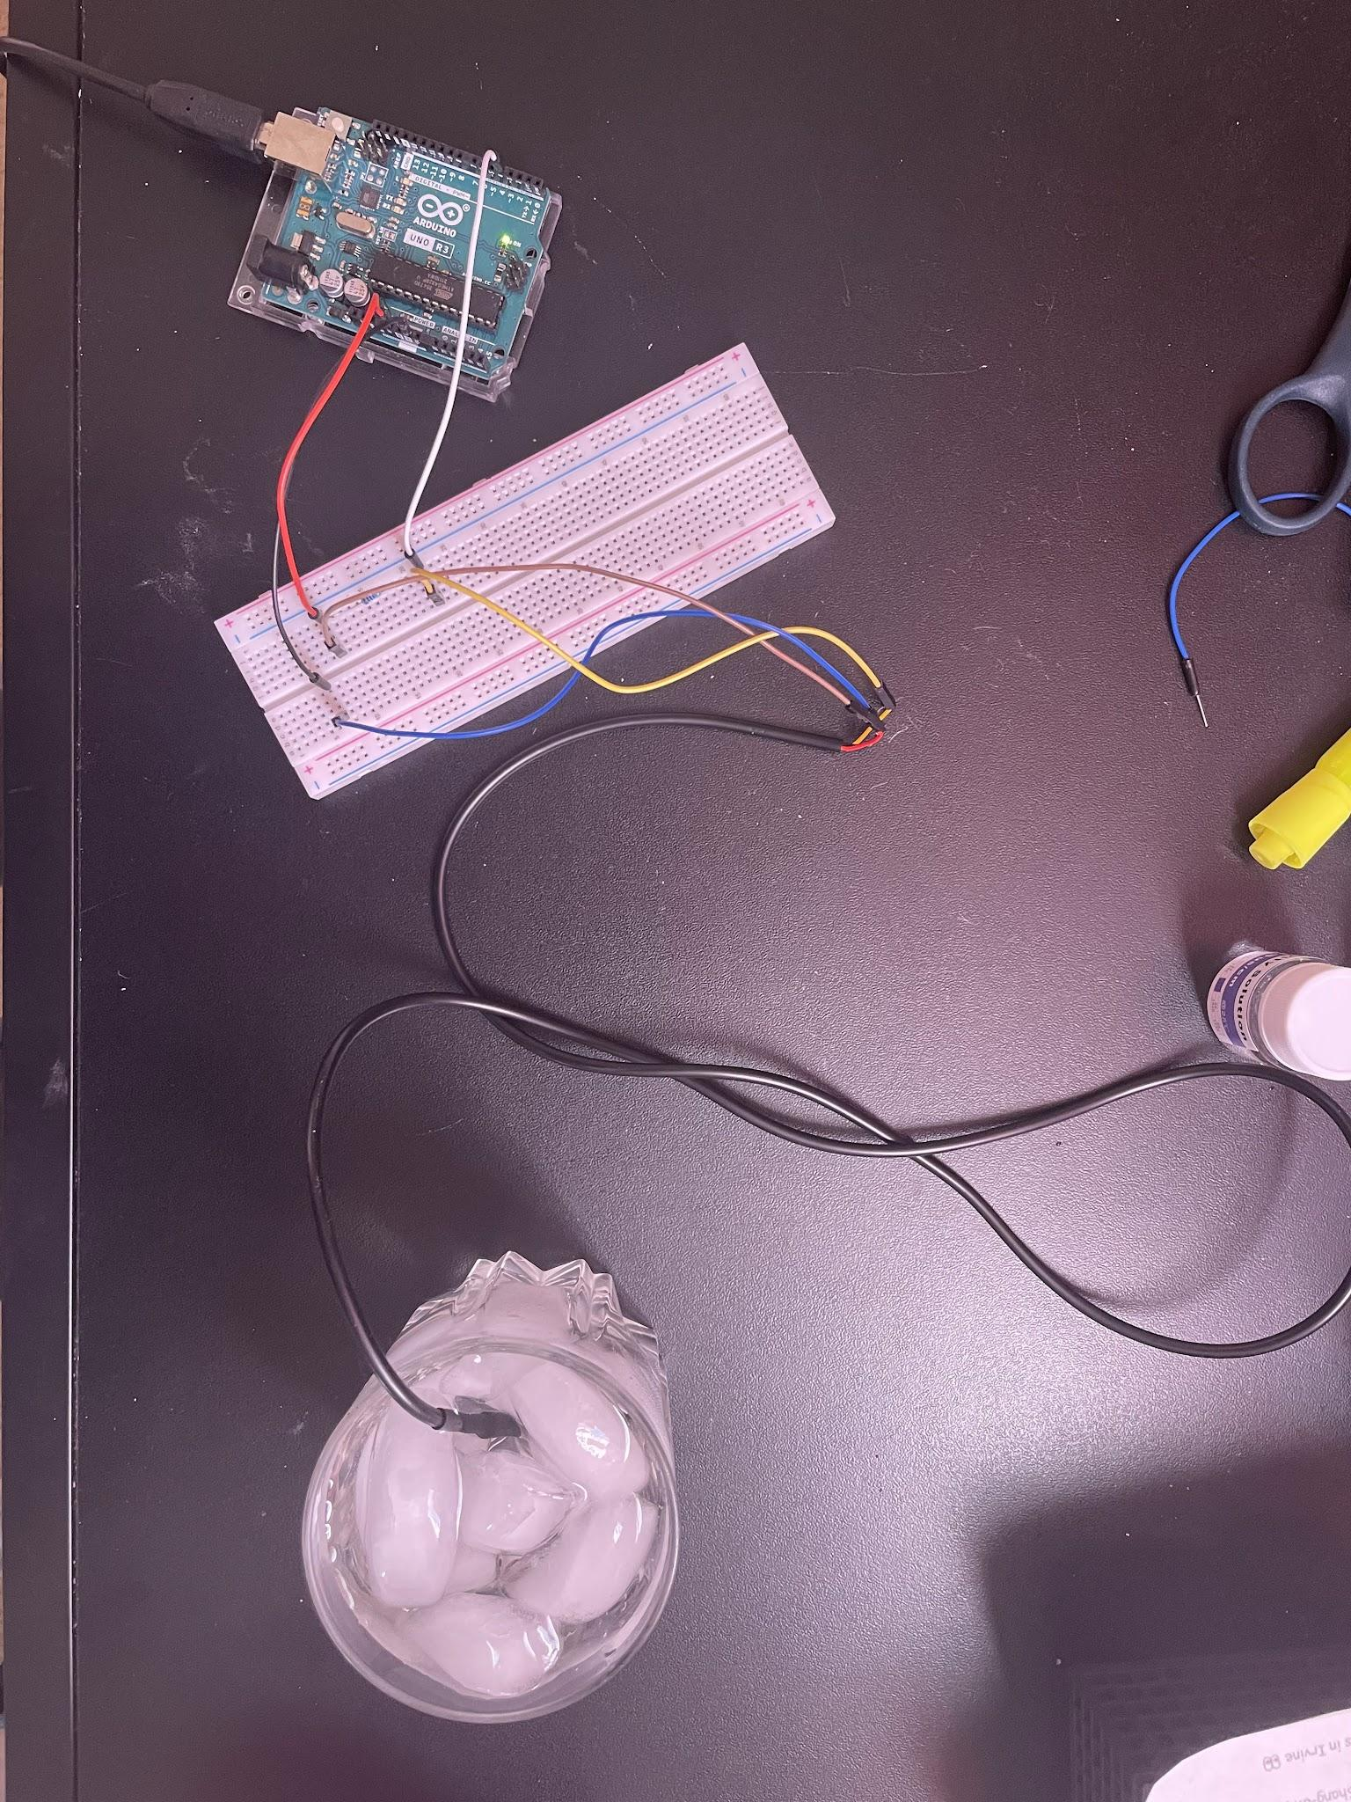

**Left: Results for ice water test. Temperatures continued to lower as the ice further chilled the water.**

**Right: Temperature probe in ice water.**

**Conclusion:**

The GikFun DS18B20 Waterproof Sensor seems to be well in working order. Luckily, should this one stop working, the pack we ordered came with 5, so we can just swap it out with one of the other probes. Initially, I was having a lot of trouble getting readings. It would simply output -127° . It turned out to be simple fixes, as I had just set up the resistor incorrectly, and then had found I just had to secure the connections with the jumper cables and the sensor cables better. The next step will be to combine this sensor with the EC Sensor, to properly compensate for water temperature, and then combine both with the pH Sensor to have all of the proper measurements needed for our prototype.

**References:**

<http://www.gikfun.com/sensors-c-8/ds18b20-temp-sensor-thermal-probe-thermometer-waterproof-p-130.html>

<https://create.arduino.cc/projecthub/TheGadgetBoy/ds18b20-digital-temperature-sensor-and-arduino-9cc806>

<http://cdn.sparkfun.com/datasheets/Sensors/Temp/DS18B20.pdf>